Health Research BC REDCap
System Validation Certificate
REDCap Release Version 11.1
Overview
This document details the validation results of the Health Research BC REDCap system, which is hosted by Population Data BC and managed by the Health Research BC Data Management (DM) team.
Project-specific validation is the responsibility of the research/project team, as detailed in the validation plan.
The DM team runs test scripts for each functionality categorized as core. Test scripts are executed to test the defined core functionalities. To accept Health Research BC REDCap as validated the following conditions must be achieved:
- All scripts must be run by 2 or more members of the DM team; primarily a programmer and coordinator
- All steps in all scripts must Pass and be documented
  - The validation certificate must be signed off by Health Research BC REDCap Leads.
Validation Results
REDCap version 11.1 has been tested by the Health Research BC DM Team with support of Population Data BC in March 2022, all tests were documented as passed. The application is considered to meet requirements for its intended use.
Installation
System Details
System Name | Health Research BC REDCap
Version | 11.1
Installation Date | March 2nd, 2022 at 1600 PST

Authorization
Release Approved by : | Signature : | Date :
Elodie Portales-Casamar, PhD  Director, Research Informatics  BC Children's Hospital Research Institute  tel: 604 875 2345 ext 4687  cell: 604 345 3181  eportales-casamar@bcchr.ca |  | March 2nd, 2022
Victor Espinosa  Manager, Research Informatics/Statistics  Vancouver Island Health Authority  victor.espinosa@islandhealth.ca | 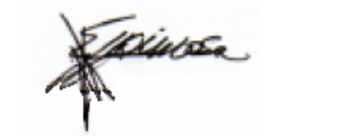 | March 2nd, 2022

